1. 0v
2. 0v
3. 0.5V
4. -0,00005A
5. -0.5V
6. -0.5v🡪0.5v
7. -1

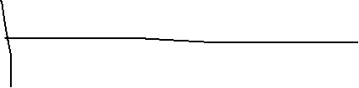

1. 10k